**CSS**

**Introduction**

CSS is a language that describes the style of an HTML document.

CSS describes how HTML elements should be displayed.

This tutorial will teach you CSS from basic to advanced.

**Eg:**

<!DOCTYPE html>

<html>

<head>

<style>

body {

background-color: lightblue;

}

h1 {

color: white;

text-align: center;

}

p {

font-family: verdana;

font-size: 20px;

}

</style>

</head>

<body>

<h1>My First CSS Example</h1>

<p>This is a paragraph.</p>

</body>

</html>

**What is CSS?**

* **CSS** stands for **C**ascading **S**tyle **S**heets
* CSS describes **how HTML elements are to be displayed on screen, paper, or in other media**
* CSS **saves a lot of work**. It can control the layout of multiple web pages all at once
* External stylesheets are stored in **CSS files**

## Why Use CSS?

CSS is used to define styles for your web pages, including the design, layout and variations in display for different devices and screen sizes.

## CSS Syntax

A CSS rule-set consists of a selector and a declaration block:

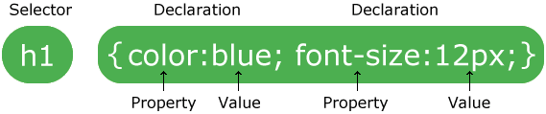

The selector points to the HTML element you want to style.

The declaration block contains one or more declarations separated by semicolons.

Each declaration includes a CSS property name and a value, separated by a colon.

Multiple CSS declarations are separated with semicolons, and declaration blocks are surrounded by curly braces.

### Example

In this example all <p> elements will be center-aligned, with a red text color:

p {  
  color: red;  
  text-align: center;  
}

#### Example Explained

* p is a **selector** in CSS (it points to the HTML element you want to style: <p>).
* color is a property, and red is the property value
* text-align is a property, and center is the property value